Requirements

**Target:** Create a webservice for saving/loading staffing level requirements for a scheduling software. These staffing levels are defined as minimum, target, maximum values of activities for different groups.

The result should be given as visual studio solution incl. a database with test data.

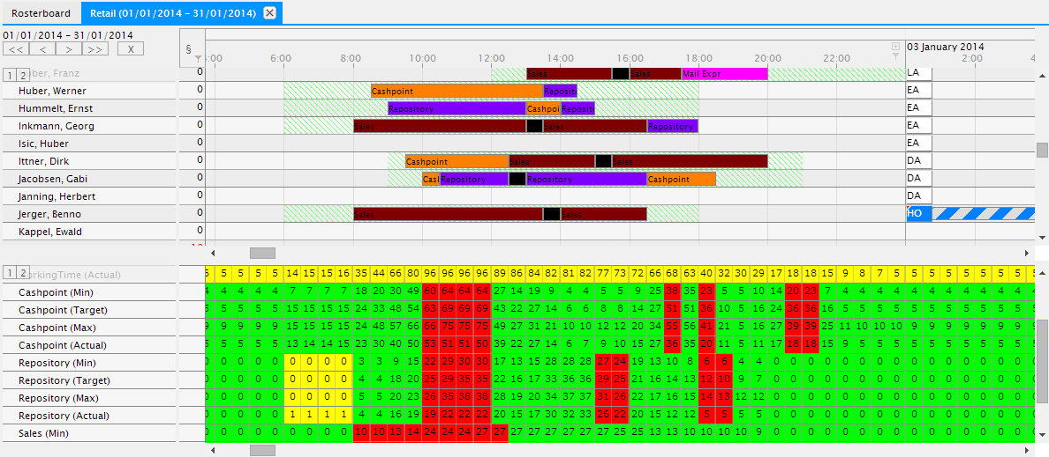

**Data structure**

* <group> <activity> <minimum/target/maximum values> in a specific <time raster>
* For a <group> staffing levels (minimum/target/maximum values) can be saved for different <activity>s.
* <group>s are e.g. group 1, group 2, group 3
* <activity>s are e.g. cashpoint, repository, sales.
* The time raster is a time period of 15, 30, 60 (full day) or 1440 minutes.

**Environment**

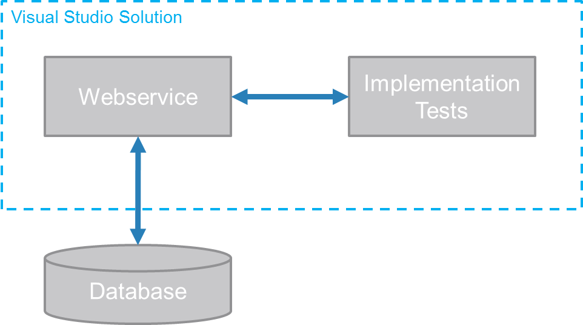

1. Creating a data access layer with methods for reading and writing data
   1. Data access should scale in environments with large amount of groups (up to 1.000) and activities (up to 100 per group) and with time raster of 15min over a time period of 10-20 years of numbers.
   2. How to save data in the database schema (table structure, indices)?
      1. How to create a table structure if there are lots of changes between the 15min-intervals?
      2. How to create a table structure if there are less changes between the 15min-intervals?
   3. How to read/save the numbers in a performant way (on base of new technology)?
   4. Writing a second time different values should overwrite existing data.
2. Creating a web service
   1. Web service provides and stores the staffing level data in an efficient way.
      1. Ask web service for many groups and activities and return the data.
      2. Where are the constraints of reading/writing data? (e.g. can we write/read Gigabytes of data?; how fast can the staffing levels be loaded?)
3. Implementation tests
   1. Coded tests which test the read/save-methods from/to the webservice.
   2. How could performance-tests look like?

Technical requirements

* Visual Studio Solution
* Current .NET Framework
* C# language